LAB #08:
Name:Mohum din_ ________________ Reg #: _F2025 1028_________________ Marks:10

Lab8: nested for loop

Task 1:Write a C++ program that asks the user to enter any integer number. The program should separate the number into its individual digits, add all the digits together, and display the total sum. For example, if the user enters 345, the program should calculate 3 + 4 + 5 = 12 and show the sum as 12.
#include <iostream>
using namespace std;

int main() {
int num, sum = 0;

cout << "Enter any integer number: ";
cin >> num;

// Convert to positive if negative
if (num < 0) {
num = -num;
}

while (num > 0) {
int digit = num % 10;
sum += digit;
num = num / 10;
}

cout << "Sum of digits = " << sum << endl;

return 0;
}

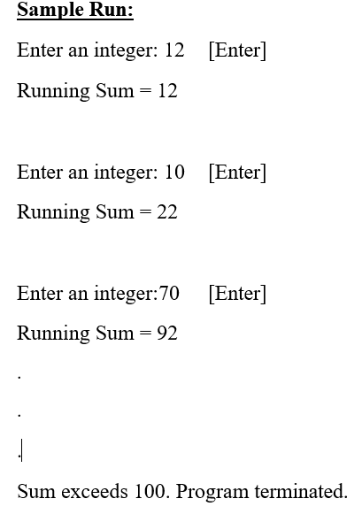
Task 2:Write a program that continuously asks user to enter an integer and displays the SUM of the current input with all previous input. The program continuous to run until the SUM value is less than equal to 100.e while() loop.

#include <iostream>
using namespace std;

int main() {
int num;
int sum = 0;

while (sum <= 100) {
cout << "Enter an integer: ";
cin >> num;

sum += num;

cout << "Current Total Sum = " << sum << endl;
}

cout << "\nProgram stopped " << endl;

return 0;
}

Task3: Write a program to print following pattern using nested for loop (do not use if, if-else or any other decision making statement). CLO1,CLO2,CLO3
* * * * * * * *
* * * * * * * *
* * * * * * * *
* * * * * * * *
#include <iostream>
using namespace std;

int main() {
for (int i = 1; i <= 4; i++) {
for (int j = 1; j <= 8; j++) {
cout << "* ";
}
cout << endl;
}

return 0;
}

Task4: Write a program to print following pattern using nested for loop (do not use if, if-else or any other decision making statement). CLO1,CLO2,CLO3
*
* *
* * *

Task4: Write a program to print following pattern using nested for loop (do not use if, if-else or any other decision making statement). CLO1,CLO2,CLO3
*
* *
* * *
* * * *
* * * * *
#include <iostream>
using namespace std;

int main() {

for (int i = 1; i <= 5; i++) {
for (int j = 1; j <= i; j++) {
cout << "* ";
}

cout << endl;
}

return 0;
}

Task 5 : Write a program to print following pattern using nested for loop (do not use if, if-else or any other decision making statement). CLO1,CLO2,CLO3
1
1 2
1 2 3
1 2 3 4
1 2 3 4 5
#include <iostream>
using namespace std;

int main() {
for (int i = 1; i <= 5; i++) {
for (int j = 1; j <= i; j++) {
cout << j << " ";
}

cout << endl;
}

return 0;
}

Task 6: Write a program to print following pattern using nested for loop (do not use if, if-else or any other decision making statement). CLO1,CLO2,CLO3
Multiplication Table (1 to 5):
-------------------------------
1 2 3 4 5
2 4 6 8 10
3 6 9 12 15
4 8 12 16 20
5 10 15 20 25
#include <iostream>
using namespace std;

int main() {
for (int i = 1; i <= 5; i++) {
for (int j = 1; j <= 5; j++) {
cout << i * j << "\t";
}
}
return 0;
}

